ZYNQCLOUD - SECURE SELF-HOSTED FILE CLOUD STORAGE
A PROJECT REPORT
Submitted By
DINESH M (310122104016)
KISHORE S (310122104042)
In partial fulfillment for the award of the degree
of
BACHELOR OF ENGINEERING
in
COMPUTER SCIENCE AND ENGINEERING
ANAND INSTITUTE OF HIGHER TECHNOLOGY,CHENNAI



ANNA UNIVERSITY: CHENNAI 600 025
APRIL 2026

ANAND INSTITUTE OF HIGHER TECHNOLOGY
(An Autonomous Institution)

DEPARTMENT OF COMPUTER SCIENCE AND ENGINEERING BONAFIDE CERTIFICATE

Certified that this project " ZYNQCLOUD - SECURE SELF-HOSTED FILE CLOUD STORAGE " is the Bonafide work of DINESH M (310122104016) and KISHORE S (310122104042) who carried out the project work under my supervision.

SIGNATURE SIGNATURE

Mrs. M Maheswari, M.E., (Ph.D) Mrs. M Maheswari, M.E., (Ph.D)

HEAD OF THE DEPARTMENT HEAD OF THE DEPARTMENT
Department of Computer Science and Department of Computer Science
Engineering, and Engineering,
Anand Institute of Higher Technology, Anand Institute of Higher
Kazhipattur, Chennai-603103
Kazhipattur, Chennai- 603103

INTERNAL EXAMINER EXTERNAL EXAMINER

ACKNOWLEDGEMENT

First and foremost, we thank the almighty, for showering his abundant blessings on us to successfully complete the project. Our sincere thanks to, our beloved "Kalvivallal" Late Thiru T. Kalasalingam, B.Com., Founder for his blessings towards us.
Our sincere thanks and gratitude to our SevaRatna Late Dr. K. Sridharan, M.Com., MBA., M.Phil., Ph.D., Chairman, Dr. S. Arivazhagi, M.B.B.S., Secretary for giving us the necessary support during the project work. We convey our thanks to our Dr.K. Karnavel, M.E., Ph.D., Principal for his support towards the successful completion of this project.
We wish to thank our Head of the Department M. Maheswari, M.E.,(Ph.D) and our Project Coordinator and Guide for the co-ordination and better guidance and constant encouragement in completing in this project.
We also thank all the Staff members of the Department of Computer Science and Engineering for their commendable support and encouragement to go ahead with the project in reaching perfection.
Last but not the least our sincere thanks to all our parents and friends for their continuous support and encouragement in the successful completion of our project.

ABSTRACT

The ZynqCloud presents the design and development of a Secure Self-Hosted File Cloud Storage platform, built using Next.js 15, NestJS 10, and PostgreSQL. The platform serves as a comprehensive self-hosted cloud storage solution enabling users to securely upload, manage, share, and download files with complete data privacy and control. The primary objective of the project is to deliver a modern, responsive, and secure web application that provides seamless file management while ensuring data sovereignty through self-hosting. The system integrates a PostgreSQL backend with TypeORM for secure data storage, coupled with a RESTful API architecture for dynamic data operations including file management, user authentication, and role-based access control. Tailwind CSS ensures a clean, consistent, and mobile-friendly interface, while Next.js leverages server-side rendering (SSR) for enhanced performance. The backend implements AES-256-GCM encryption for files at rest using a Master Key Encryption (KEK) hierarchy with per-file Data Encryption Keys (DEK), ensuring that stored files remain encrypted and secure. Additional modules include JWT-based authentication with HTTP-only cookies, invite-only registration, public and private file sharing with password protection, storage quota management, and SMTP-based email notifications. Through this project, a fully functional production-grade self-hosted cloud storage platform was created that enables organizations and individuals to maintain complete control over their data while providing features comparable to commercial cloud storage services.

TABLE OF CONTENTS
CHAPTER TITLE PAGE NO
 | ABSTRACT | iv
 | LIST OF FIGURES | vii
 | LIST OF ABBREVATIONS | viii
 | LIST OF TABLES | ix
1. | INTRODUCTION | 10
1.1 | OBJECTIVE | 11
1.2 | SCOPE | 12
2. | LITERATURE SURVEY | 13
3. | ANALYSIS | 19
3.1 | SYSTEM ANALYSIS | 19
3.1.1 | PROBLEM IDENTIFICATION | 19
3.1.2 | EXISTING SYSTEM | 19
3.1.3 | PROPOSED SYSTEM | 19
3.2 | REQUIREMENT ANALYSIS | 20
3.2.1 | FUNCTIONAL REQUIREMENTS | 20
3.2.2 | NON-FUNCTIONAL REQUIREMENTS | 21
3.2.3 | HARDWARE SPECIFICATION | 22
3.2.4 | SOFTWARE SPECIFICATION | 22
4. | DESIGN | 23
4.1 | OVERALL DESIGN | 23
4.2 | UML DIAGRAMS | 24
5. | IMPLEMENTATION | 29
5.1 | MODULES | 29
5.2 | MODULE DESCRIPTION | 29
6. | TESTING | 33
6.1 | TESTING AND VALIDATION | 33
6.2 | BUILD THE TEST PLAN | 35
7. | RESULTS AND DISCUSSION | 37
8. | USER MANUAL | 40
9. | CONCLUSION | 42
10. | FUTURE ENHANCEMENT | 43
 | APPENDIX-II SCREENSHOTS | 44

LIST OF FIGURES
FIGURE NO | FIGURE DESCRIPTION | PAGE NO
4.1 | Proposed System Architecture | 23
4.2 | Workflow Diagram | 24
4.3 | Use Case Diagram | 25
4.4 | Class Diagram | 26
4.5 | Activity Diagram | 27
4.6 | Sequence Diagram | 28

LIST OF ABBREVATIONS
SYMBOLS | ABBREVIATIONS
API | Application Programming Interface
SSR | Server Side Rendering
UI | User Interface
UX | User Experience
SMTP | Simple Mail Transfer Protocol
SDK | Software Development Kit
SQL | Structured Query Language
HTTP | Hypertext Transfer Protocol
DNS | Domain Name System
CSS | Cascading Style Sheets
JWT | JSON Web Token
RBAC | Role-Based Access Control
AES | Advanced Encryption Standard
GCM | Galois/Counter Mode
KEK | Key Encryption Key
DEK | Data Encryption Key
IV | Initialization Vector
ORM | Object-Relational Mapping
REST | Representational State Transfer
CORS | Cross-Origin Resource Sharing
DTO | Data Transfer Object
UUID | Universally Unique Identifier
CRUD | Create, Read, Update, Delete
SHA | Secure Hash Algorithm
E2EE | End-to-End Encryption

LIST OF TABLES
TABLE NO | TABLE NAME | PAGE NO
6.1 | Test Case Design | 36
6.2 | Test Case Log | 36

CHAPTER 1
INTRODUCTION
In today’s digital era, data privacy and ownership have become critical concerns as individuals and organizations increasingly rely on cloud storage services offered by third-party providers such as Google Drive, Dropbox, and OneDrive. While these services offer convenience and scalability, they raise significant privacy issues as users’ data is stored on remote servers controlled by the service provider, leaving it vulnerable to unauthorized access, data mining, and potential breaches. ZynqCloud – Secure Self-Hosted File Cloud Storage was developed to address these concerns by providing a comprehensive, open-source cloud storage platform that users can deploy on their own infrastructure, ensuring complete data sovereignty and privacy.
The main goal of the project is to build a secure, self-hosted alternative to commercial cloud storage services that gives users full control over their data while maintaining the convenience and feature-richness of established platforms. The project is built using Next.js 15 and NestJS 10, combining modern frontend capabilities with a robust backend architecture. Next.js, a React-based framework, offers features like Server-Side Rendering (SSR) for improved loading speed and user experience, while Tailwind CSS ensures visually consistent, mobile-responsive layouts. The backend is powered by NestJS with TypeORM, which manages all data entities in PostgreSQL including users, files, shares, invitations, and settings.

A key differentiator of ZynqCloud is its implementation of AES-256-GCM encryption for files at rest, using a hierarchical key management system with Master Key Encryption (KEK) and per-file Data Encryption Keys (DEK). This ensures that even if the storage media is compromised, the file contents remain encrypted and unreadable. The system supports both private sharing between registered users and public sharing via tokenized links with optional password protection and expiration dates.
The project encompasses the complete lifecycle of a modern web application, covering requirements analysis, system design, UI development, backend integration, encryption implementation, testing, and Docker-based deployment. It provides real-world exposure to full-stack web development using modern frameworks and emphasizes industry practices such as role-based access control, API-driven architecture, and containerized deployment workflows. This system not only provides secure file storage for users but also enhances administrative efficiency through storage monitoring, user management, and invite-based registration.

1.1 OBJECTIVE

- To design and develop a secure, self-hosted file cloud storage platform using Next.js 15 and NestJS 10 with PostgreSQL as the database.
- To implement AES-256-GCM file-at-rest encryption with a hierarchical key management system (KEK/DEK) to ensure data confidentiality.
- To create a user-friendly platform that enables file upload, download, organization, sharing, and trash management with role-based access control.
- To integrate JWT-based authentication with HTTP-only cookies, invite-only registration, and role hierarchy (Owner, Admin, User) for secure access management.
- To implement both public and private file sharing mechanisms with password protection, expiration controls, and permission-based access.
- To provide administrative capabilities including user management, storage quota allocation, monitoring dashboards, and SMTP-based email notifications.
- To deploy the application using Docker containers for easy self-hosting and infrastructure independence.

1.2 SCOPE

- The project covers the complete lifecycle of a dynamic web application, including requirement analysis, system design, frontend and backend development, database integration, encryption implementation, testing, and containerized deployment.
- It provides practical exposure to Next.js 15 framework for server-side rendering, NestJS 10 for backend API development, and TypeORM for database management with PostgreSQL.
- The system manages all key functionalities of cloud storage — from file upload and download to sharing, trash management, and storage quota enforcement.
- It ensures secure handling of user data through AES-256-GCM encryption at rest, bcrypt password hashing, JWT authentication, and rate limiting.
- The platform supports self-hosting through Docker containerization, allowing organizations to deploy on their own infrastructure with complete data sovereignty.
- The project demonstrates how modern web technologies combined with encryption systems can provide a secure alternative to commercial cloud storage, reducing dependency on third-party services while maintaining feature parity.

CHAPTER 2

LITERATURE SURVEY

Title : Secure Outsourcing and Sharing of Cloud Data Using a
User-Side Encrypted File System
Author : Osama Ahmed Khashan
Year : 2020
Publication : IEEE Access (Institute of Electrical and Electronics Engineers)
Concept Discussed :
The paper introduces OutFS, a user-side encrypted file system designed to provide transparent encryption for stored and shared outsourced data in cloud environments. It utilizes a hybrid encryption scheme combining symmetric and asymmetric methods, where files are encrypted locally before being uploaded to cloud storage. The key management is designed for convenience using identity-based encryption (IBE) for secure data sharing among multiple users. The system preserves the integrity of outsourced file data and file system structure through cryptographic mechanisms.
Work Done :
The researchers designed and implemented OutFS as a FUSE-based file system that intercepts file operations at the user level to automatically encrypt and decrypt data. A hybrid encryption structure was developed using AES for file content encryption and IBE for key distribution during sharing. The system achieves an average throughput of 8.8 MB/sec for writing and 10.5 MB/sec for reading outsourced files. Security analysis demonstrated robustness against brute-force, eavesdropping, man-in-the-middle, and offline-dictionary attacks.
Knowledge Gained :
From this paper, we gained critical understanding of user-side encryption architectures for cloud storage, particularly the approach of encrypting data transparently before it leaves the user’s system. The hybrid encryption model combining symmetric encryption for performance with asymmetric methods for key management directly influenced ZynqCloud’s design of using AES-256-GCM with a Master Key (KEK) and per-file Data Encryption Keys (DEK). The concept of preserving data integrity through authentication tags aligned with our implementation of GCM authentication.
Gap :
While OutFS provides robust encryption and sharing capabilities, it requires installation of a FUSE-based file system on the user’s operating system, limiting accessibility to technically proficient users. The system lacks a web-based interface for file management, does not support role-based access control for organizational use, and has no built-in storage quota management. Additionally, the sharing mechanism relies on IBE infrastructure which adds complexity. ZynqCloud addresses these gaps by providing a web-based platform with built-in encryption, RBAC, storage quotas, and Docker-based deployment requiring no client-side software installation.
Title : Secure File Sharing System Using Big Data in the Cloud
Author : Ashwani Kumar Singh, Harshit Shukla, Adarsh Sonkar, Veena Mittal
Year : 2023
Publication : 5th International Conference on Advances in Computing,
Communication Control and Networking (ICAC3N), IEEE
Concept Discussed :
The paper proposes a secure file sharing application that enables users to share documents, images, and other data without size limitations through cloud-based storage. It addresses security concerns by implementing encryption and decryption modules with hash-based key exchange between sender and receiver. The system uses MongoDB for handling structured, semi-structured, and unstructured data, and distributes encrypted file fragments across multiple cloud storage platforms to prevent unauthorized access even if one cloud is compromised.
Work Done :
The researchers developed a web-based file sharing application with three core modules: encryption and decryption using hash-based key generation, a multi-cloud storage distribution system that splits encrypted data across different cloud providers, and a database management module using MongoDB for metadata and user management. The system supports files up to 1GB with automatic link expiration and database cleanup to optimize storage. Security was enhanced through network-level, access-level, and administration-level controls provided by MongoDB.
Knowledge Gained :
This paper reinforced the importance of combining encryption with access control for cloud file sharing applications. The concept of hash-based key exchange for secure sharing influenced our approach to share token generation with optional password protection. The emphasis on eliminating file size limitations and providing a user-friendly web interface aligned with ZynqCloud’s design goals. The discussion of unnecessary data storage optimization informed our implementation of soft-delete with trash management.
Gap :
The system relies on distributing data across multiple third-party cloud providers, which introduces dependency on external services and increases complexity. It lacks user-side encryption before upload, meaning the application server has access to plaintext data. There is no role-based access control, no per-user storage quotas, and no self-hosting capability. The hash-based key exchange requires manual key sharing between users. ZynqCloud addresses these gaps through self-hosted deployment, server-side AES-256-GCM encryption at rest, RBAC with three-tier hierarchy, and automated share token management without manual key exchange.

Title : Cloud Storage and Secure File Sharing using Blockchain with Xchacha20 and Shake Cryptography
Author : J. Jayachitra, H. Arshad, R. Muthukumaran
Year : 2024
Publication : 16th IEEE International Conference on Computational
Intelligence and Communication Networks (CICN)
Concept Discussed :
The paper proposes a decentralized file sharing and storage system based on blockchain technology, using SHAKE-256 for cryptographic hashing and XChaCha20 for end-to-end file encryption. The system emphasizes eliminating dependence on centralized storage solutions that are vulnerable to single points of failure. Smart contracts manage access control policies, determining group membership and file permissions. The blockchain records file metadata, content identifiers (CIDs), and access control information while encrypted files are stored off-chain.
Work Done :
The researchers implemented a blockchain network using SHAKE-256 for transaction hashing with variable-length outputs, providing flexibility in blockchain record design. XChaCha20 encryption was applied to all uploaded files with keys managed through the blockchain, ensuring only authorized group members can decrypt. Smart contracts enforce dynamic access control based on group membership. The system was tested for security resistance against brute-force attacks, collision attacks, and unauthorized access, demonstrating effective data confidentiality, integrity, and accessibility.
Knowledge Gained :
This paper provided insights into advanced encryption algorithms beyond AES, particularly the stream cipher XChaCha20 with its extended 24-byte nonce providing stronger protection against nonce reuse. The concept of separating encrypted file storage from metadata management on blockchain parallels ZynqCloud’s approach of storing encrypted files on disk while maintaining metadata in PostgreSQL. The group-based access control model informed our understanding of permission-based sharing mechanisms.
Gap :
The blockchain-based approach introduces significant computational overhead for transaction processing and consensus mechanisms, making it impractical for high-frequency file operations in a personal or small-team cloud storage context. The system requires blockchain infrastructure setup and maintenance, which contradicts the goal of simple self-hosting. There is no web-based user interface described, no storage quota management, and the group-based access control lacks the flexibility of individual file-level sharing. ZynqCloud provides a lightweight alternative with comparable encryption security through AES-256-GCM, without the blockchain overhead, while offering a full web interface and granular per-file sharing.

Title : Secure Remote Cloud File Sharing With Attribute-Based Access Control and Performance Optimization
Author : E. Chen, Yan Zhu, Kaitai Liang, Hongjian Yin
Year : 2023
Publication : IEEE Transactions on Services Computing
Concept Discussed :
The paper presents a secure cloud file sharing framework integrating enterprise-side Attribute-Based Access Control (ABAC) with the XACML standard and client-side Ciphertext-Policy Attribute-Based Encryption (CP-ABE) from lattice-based cryptography. The framework supports encrypted file writing and reading in accordance with ABAC/XACML-based access policies. A key contribution is the Small Policy Matrix (SPM) optimization algorithm that reduces cumulative errors in lattice-based encryption, improving both performance and parameter sizes for post-quantum security.
Work Done :
The researchers designed a framework workflow supporting encrypted file operations on cloud file sharing services like Google Drive and OneDrive. They developed an optimal Small Policy Matrix generation algorithm that produces matrices with only small elements and all-one reconstruction vectors, minimizing error amplification in lattice-based cryptosystems. The improved CP-ABE scheme achieves shorter parameters and efficient computation compared to existing lattice-based approaches. The system was evaluated for parameter sizes, computation overhead, and storage costs, demonstrating practical improvements for enterprise cloud file sharing.
Knowledge Gained :
This paper deepened our understanding of attribute-based access control as an alternative to traditional role-based systems, particularly for enterprise environments with complex sharing policies. The integration of encryption with access control at the framework level, rather than as separate concerns, influenced ZynqCloud’s design of tightly coupling the Encryption Module with the File Sharing Module. The discussion of post-quantum cryptography considerations highlighted the importance of designing systems with future cryptographic upgradability in mind.
Gap :
The CP-ABE scheme from lattice-based cryptography introduces significant computational complexity that is currently impractical for real-time file operations in consumer-grade applications. The ABAC/XACML policy framework requires extensive enterprise infrastructure for policy administration and attribute credential management. The system is designed for integration with existing commercial cloud services rather than self-hosted deployment, and lacks user-friendly web interfaces for non-technical users. ZynqCloud addresses these gaps by implementing efficient AES-256-GCM encryption with practical performance, a simple three-tier RBAC model suitable for small

CHAPTER 3

ANALYSIS

3.1 SYSTEM ANALYSIS

3.1.1 Problem Identification
In the current digital landscape, users rely on commercial cloud storage providers like Google Drive, Dropbox, and OneDrive for file storage and sharing. However, these services store data on third-party servers where users have limited control over data privacy and security. Data breaches, unauthorized data mining, vendor lock-in, and compliance concerns have driven the need for self-hosted alternatives that give organizations full control over their data while maintaining the usability and feature-richness of commercial solutions.

3.1.2 Existing System
Existing self-hosted cloud storage solutions such as Nextcloud and ownCloud provide alternatives to commercial services. However, they often require complex setup procedures, have heavy resource requirements, and lack modern UI/UX design. Many solutions use outdated frontend technologies, offer limited built-in encryption, and require extensive plugin management for basic features. Additionally, most existing platforms do not implement per-file encryption at rest by default, relying instead on filesystem-level encryption which leaves files readable to anyone with server access.

3.1.3 Proposed System
The proposed solution implements a modern, lightweight self-hosted cloud storage platform using Next.js 15 for the frontend and NestJS 10 for the backend, with PostgreSQL for data management. The system features AES-256-GCM encryption at rest with hierarchical key management, JWT-based authentication with role-based access control, file sharing with password protection and expiration, storage quota management, and Docker-based deployment for easy self-hosting.
3.2 REQUIREMENT ANALYSIS

3.2.1 Functional Requirements
File Management:
The system should provide comprehensive file management capabilities including file upload with drag-and-drop support, file download with proper streaming, folder creation and hierarchical organization, and soft-delete with trash recovery. Files should be automatically encrypted upon upload and decrypted upon download.
File Encryption:
All uploaded files should be encrypted at rest using AES-256-GCM with a Master Key (KEK) and per-file Data Encryption Keys (DEK). Each file receives a unique 32-byte encryption key and 12-byte initialization vector, with GCM authentication tags providing integrity verification.

User Authentication:
The system should implement JWT-based authentication with HTTP-only cookies, supporting secure login, invite-based registration, password reset via email tokens, and profile management with password change functionality.
Role-Based Access Control:
Implement a three-tier role hierarchy with Owner (full system control and initial setup), Admin (user management, invitation creation, storage monitoring), and User (file management and sharing) roles, each with appropriate permissions enforced through NestJS guards.
File Sharing:
Support both private sharing (user-to-user with READ/WRITE permissions) and public sharing (tokenized links with optional password protection and configurable expiration dates). The module should support folder sharing, share revocation, and download tracking.
Storage Management:
Provide per-user storage quota management with real-time usage tracking, administrative quota adjustment, system-wide storage monitoring, and enforcement that prevents uploads exceeding allocated limits.
Admin Dashboard:
Provide an administrative interface to view and manage all registered users, create and revoke invitations with role assignment, monitor storage usage across the system, and configure application settings.

Email Notification System:
Implement SMTP-based email notifications for delivering invitation links with secure tokens, password reset emails with time-limited tokens, and system alerts, using HTML templates with proper sanitization.

3.2.2 Non-Functional Requirements:
Performance:
The system should handle multiple concurrent file operations efficiently with minimal latency. Server-side rendering should deliver fast initial page loads, and file streaming should support large file downloads without memory overflow.
Security:
Ensure AES-256-GCM encryption for files at rest, bcrypt password hashing with salt rounds, rate limiting at 100 requests per minute with stricter limits on authentication endpoints, CORS protection, and input validation through class-validator DTOs with whitelist enforcement.
Scalability:
Support increasing numbers of users, files, and storage capacity without performance degradation. PostgreSQL indexing, TypeORM connection pooling, and Docker volume management must accommodate future growth.

Reliability:
Ensure data integrity through SHA256 hash verification for duplicate detection, soft-delete with recovery capability, Docker health checks with automatic container restart policies, and proper error handling with standardized responses.
Maintainability:
Follow a modular monorepo architecture using Turborepo with shared packages (@zynqcloud/ui, @zynqcloud/shared-types), enabling independent development, testing, and deployment of frontend, backend, and shared libraries.
Portability:
Support deployment across any infrastructure via Docker containers, with compatibility across Linux, macOS, and Windows host environments, and flexible configuration through environment variables.

3.2.3 Hardware Specifications
Processor : Intel i5 or equivalent
RAM : 8 GB
Storage : 500 GB HDD or SSD
Graphics : Integrated graphics

3.2.4 Software Specifications
Operating System : Windows 10/11, macOS, or Linux
Tools : Visual Studio Code, Git, Docker Desktop, Postman
Language : TypeScript, JavaScript, SQL
Frameworks : Next.js 15, NestJS 10, React 19, Tailwind CSS 4,
Node.js 20
Database : PostgreSQL 16
Libraries : TypeORM, Passport JWT, Bcrypt, Nodemailer,
Archiver, Class-Validator, Radix UI, React Hook Form
Cloud Platforms : Docker, Any VPS/dedicated server for self-hosting

CHAPTER 4

DESIGN
4.1 OVERALL DESIGN
The overall design of ZynqCloud integrates essential modules to deliver a secure, responsive, and efficient self-hosted cloud storage experience. The Frontend Module developed using Next.js 15 and Tailwind CSS 4 provides dynamic pages for file management, sharing, and administration. The Backend Module built with NestJS 10 manages authentication, file operations, encryption, and API communication through a modular service architecture. The Database Module uses PostgreSQL 16 with TypeORM to store user accounts, file metadata, shares, invitations, and settings securely with proper indexing and referential integrity. The Encryption Module implements AES-256-GCM with a hierarchical key management system consisting of a Master Key (KEK) for encrypting per-file Data Encryption Keys (DEK). The Email Module integrates Nodemailer for automated invitation delivery and password reset notifications through SMTP configuration.

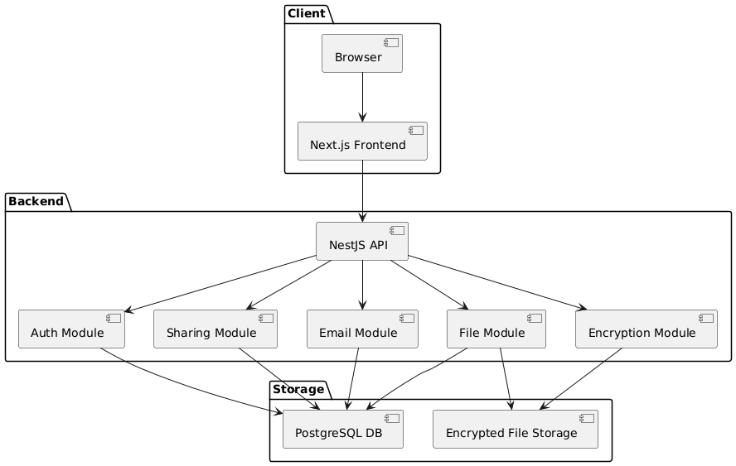

Fig 4.1 Proposed System Architecture.

4.2 UML DIAGRAMS

4.2.1 Workflow Diagram
A workflow diagram provides a visual representation of the ZynqCloud system process flow. It illustrates the complete user journey from initial registration through invitation tokens, user authentication via JWT, file upload with automatic AES-256-GCM encryption, secure storage on the server filesystem, and file sharing through both private user-to-user grants and public tokenized links.
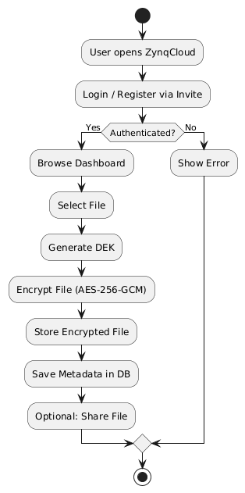

Fig 4.2 Workflow Diagram

4.2.2 Use Case Diagram
The Use Case Diagram presents the interactions between three primary actors and the ZynqCloud system. The User actor can upload files, download files, create folders, share files publicly and privately, manage trash, and update profile settings. The Admin actor inherits all User capabilities and additionally can manage users, create and revoke invitations, monitor storage usage, and adjust storage quotas.
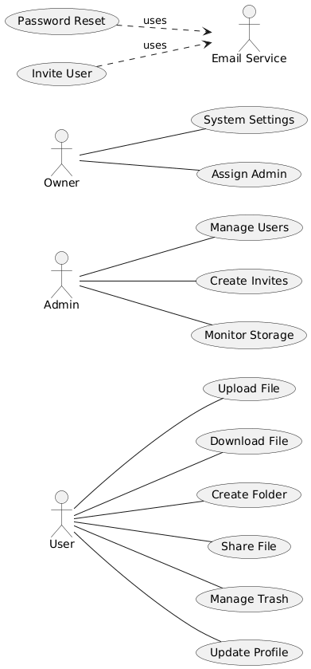
Fig 4.3 Use Case Diagram

4.2.3 Class Diagram
The Class Diagram represents the static structure of ZynqCloud, showing the relationships between seven core entities. The BaseEntity abstract class provides common fields (id, created_at, updated_at) inherited by all entities. The User entity has OneToMany relationships with File, Share, and Invitation entities.
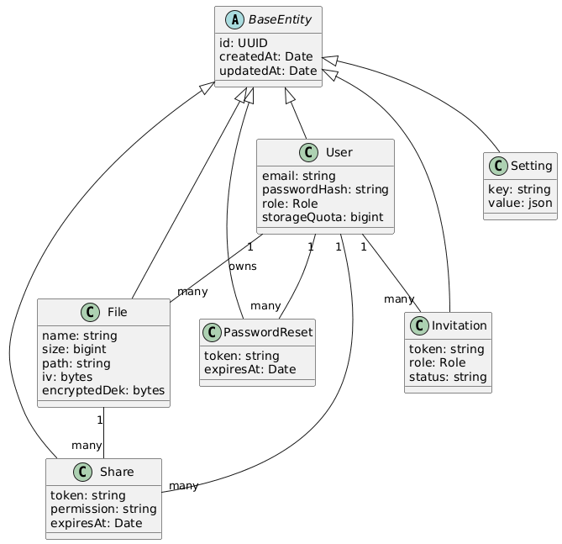

Fig 4.4 Class Diagram

4.2.4 Activity Diagram
The Activity Diagram illustrates the dynamic flow of file upload and sharing operations in ZynqCloud. The process begins with user authentication through JWT validation, followed by file selection and metadata extraction. The system then generates a unique Data Encryption Key (DEK), encrypts the file content using AES-256-GCM with a random initialization vector, stores the encrypted file on disk, encrypts the DEK with the Master Key, and saves all metadata to PostgreSQL.
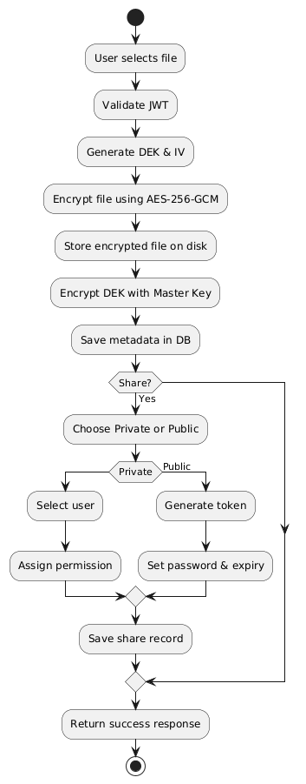
Fig 4.5 Activity Diagram

4.2.5 Sequence Diagram
The Sequence Diagram models the communication flow between five key components during a file upload operation: Client Browser, Next.js Frontend, NestJS API Server, Encryption Service, PostgreSQL Database, and File Storage. The sequence begins with the user selecting a file, the frontend computing its SHA256 hash, and sending a duplicate-check request. If no duplicate exists, the file is uploaded via multipart form data. The API Server validates the JWT, invokes the Encryption Service to generate a DEK and IV, encrypts the file content, writes the ciphertext to File Storage, encrypts the DEK with the Master Key, and stores all metadata in PostgreSQL. The response flows back with the created file’s metadata, and the frontend updates the file list and storage usage display.
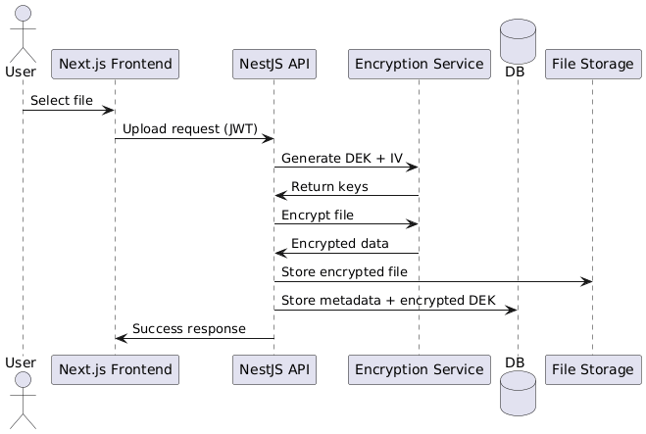
Fig 4.6 Sequence Diagram

CHAPTER 5

IMPLEMENTATION
5.1 MODULES
The project implementation follows a modular architecture using a Turborepo monorepo structure that separates concerns across independent packages. The monorepo contains two applications (client and server) and two shared packages (ui and shared-types). The development process covers front-end interface design, backend API services, database integration, encryption implementation, file sharing mechanisms, and email automation.
The list of modules are:
- Backend API Module
- Database Management Module
- Encryption Module
- File Sharing Module
- Email and Notification Module
5.2 MODULE DESCRIPTION

Backend API Module
This module handles all business logic using NestJS 10 with a modular service architecture. It implements RESTful API endpoints organized across eight core modules: Authentication, User Management, File Operations, Sharing, Invitations, Storage, Settings, and Encryption. JWT-based authentication with HTTP-only cookies secures all protected routes, with token validation through Passport strategies. Role-based guards using custom decorators (@Roles) enforce access control across the three-tier hierarchy of Owner, Admin, and User. Input validation through class-validator DTOs with whitelist enforcement and forbidNonWhitelisted options prevents malformed and malicious requests. Global exception filters standardize error responses, logging middleware tracks request patterns, and @nestjs/throttler rate limiting prevents brute-force attacks with configurable limits per endpoint.

Database Management Module
This module manages the centralized data storage using PostgreSQL 16 with TypeORM as the Object-Relational Mapper. It defines seven core entities: User, File, Share, Invitation, PasswordReset, Setting, and the abstract BaseEntity. The File entity employs a self-referential ManyToOne relationship through parent_id for unlimited folder hierarchy depth, with cascade delete operations maintaining referential integrity. Encryption metadata including the encrypted Data Encryption Key (DEK), Initialization Vector (IV), and encryption algorithm are stored as bytea columns alongside file information. BigInt columns accurately handle file sizes up to petabyte scale with careful JavaScript string-to-number conversion to prevent arithmetic errors. Foreign key constraints with ON DELETE CASCADE ensure consistent data across all entity relationships. The TypeORM configuration supports automatic schema synchronization during development and migration-based updates for production deployments.

Encryption Module
This module implements AES-256-GCM encryption for all files at rest using a hierarchical key management system. A 32-byte Master Key (KEK) stored securely as a base64-encoded environment variable serves as the root of the encryption hierarchy. For each uploaded file, the service generates a unique 32-byte Data Encryption Key (DEK) and a 12-byte random Initialization Vector (IV). The file content is encrypted using the DEK with AES-256-GCM, producing ciphertext and a 16-byte authentication tag that provides both confidentiality and integrity verification. The DEK is then encrypted with the Master Key using the same AES-256-GCM algorithm and stored in the database alongside the IV and algorithm identifier. During file download, the process reverses: the encrypted DEK is decrypted with the Master Key, and the file content is decrypted and integrity-verified using the GCM authentication tag. This approach ensures that compromising a single DEK only exposes one file, while the Master Key provides centralized key management without per-file key distribution overhead.

File Sharing Module
This module implements both private and public file sharing mechanisms with granular permission control. Private sharing allows authenticated users to grant READ or WRITE permissions to specific registered users by email address, creating Share records that link the file owner, the grantee, and the permission level. Public sharing generates cryptographically random tokens for anonymous access, with optional features including bcrypt-hashed password protection and configurable expiration timestamps. The module supports sharing of both individual files and entire folders with recursive access to contained items. Share management includes listing active shares, revoking access by the creator or file owner, and automatic expiration checking. Download operations through shares properly authenticate the request, decrypt the file using the stored DEK and IV, and stream the decrypted content to the recipient with appropriate Content-Type and Content-Disposition headers.

Email and Notification Module
This module integrates Nodemailer for SMTP-based email communication within the NestJS backend. It handles two primary workflows: invitation email delivery containing secure token links that allow new users to register with pre-assigned roles and storage quotas, and password reset notifications with time-limited tokens that expire after a configurable TTL period (default 72 hours). HTML email templates are constructed with proper sanitization to prevent XSS attacks, using URL encoding and HTML entity escaping for all dynamic content. The SMTP configuration supports various email providers including Gmail with OAuth2, custom SMTP servers with TLS/STARTTLS, and configurable sender addresses. Authenticated SMTP delivery with retry logic ensures reliable message transmission even under transient network failures.

CHAPTER 6

TESTING
6.1 TESTING AND VALIDATION
Testing and validation ensure that the developed system meets all specified requirements, performs as expected, and maintains security across various use cases. The following methods ensure software reliability, functional accuracy, and system stability throughout all development phases.
Unit Testing
Unit testing verifies that each component functions correctly in isolation. For this project, modules such as the Encryption Service (AES-256-GCM key generation, encryption, and decryption), JWT Authentication Guard (token validation and expiration), file upload validation (size limits and MIME type checking), and storage quota calculations (BigInt arithmetic with string conversion) are tested independently. API responses, TypeORM entity operations, and role-based access control guards were verified using mock inputs and dependency injection to ensure accurate data processing and error-free execution.
Functional Testing
Functional testing validates the system’s operation against functional requirements. It ensures that file upload correctly generates a DEK, encrypts the file content, and stores encrypted data with metadata. JWT authentication properly issues tokens via HTTP-only cookies, validates them on protected routes, and rejects expired or tampered tokens. Role guards correctly restrict admin endpoints from regular users. File sharing generates valid share tokens with proper permissions, and invitation-based registration correctly assigns roles and default storage quotas to new users.
Performance Testing
Performance testing measures the application’s responsiveness and stability under load. The frontend was tested for server-side rendering performance with multiple simultaneous page requests. The backend was evaluated for concurrent file upload and download operations, measuring encryption throughput for files of various sizes. Response times for API endpoints were benchmarked, targeting sub-second responses for metadata operations and efficient streaming for large file downloads without memory overflow.

Stress Testing
Stress testing evaluates the system’s behavior under extreme conditions such as multiple users uploading large files concurrently, rapid API requests exceeding the configured rate limits, and simultaneous database operations creating connection pool pressure. Docker container resource limits were tested to verify that the system operates within allocated memory and CPU bounds. PostgreSQL connection pooling through TypeORM was validated under high concurrent query loads to ensure graceful handling without connection exhaustion.

Structured Testing
Structured testing ensures systematic coverage of all possible test scenarios. File uploads with invalid MIME types, oversized files exceeding quota, duplicate SHA256 hashes, and corrupted file content were tested to verify proper rejection and error messaging. Authentication scenarios including expired JWTs, invalid tokens, forged signatures, missing cookies, and role escalation attempts were verified to confirm that security boundaries are enforced correctly at every endpoint.
System Testing
System testing validates that all modules work together as an integrated solution. This includes verifying the interaction between the Next.js frontend, NestJS backend, PostgreSQL database, Encryption Service, and file storage volume. Complete workflows from user invitation through registration, file upload with encryption, sharing via public link with password, and download with decryption were executed end-to-end to ensure seamless integration across all system components.
Integration Testing
Integration testing verifies smooth communication between different modules. This includes frontend API calls through the custom API client to backend endpoints, backend database transactions through TypeORM repositories, Encryption Service integration with file upload and download controllers, email delivery through SMTP configuration, and Docker Compose service orchestration with health check dependencies between PostgreSQL, backend, and frontend containers.
Acceptance Testing
Acceptance testing evaluates whether the system meets user and business requirements. Users can successfully register via invitation links, upload and organize files in folders, share files publicly with password protection, recover deleted files from trash, and manage their profile and password. Administrators can manage users, create and revoke invitations with role assignment, adjust storage quotas, and monitor system-wide storage usage. The Docker deployment was verified across Linux and macOS host environments to confirm cross-platform compatibility.
Synchronization Testing
This testing ensures that modules execute in the correct order and maintain data consistency. For example, it verifies that file metadata is stored in PostgreSQL only after successful encryption and physical file storage, that user storage_used is updated accurately after both upload and deletion operations, that share tokens are validated against expiration dates and passwords before allowing file access, and that invitation status transitions (PENDING → ACCEPTED / REVOKED / EXPIRED) are handled atomically to prevent race conditions.
6.2 BUILD THE TEST PLAN
The test plan defines strategies, objectives, and methods used to validate the functionality, security, encryption integrity, and performance of the system before deployment. Testing ensures proper integration of authentication, file management, encryption, sharing, and administrative modules under realistic operating conditions.
Testing was conducted using Docker containers running Node.js 20 Alpine, PostgreSQL 16 Alpine, and the NestJS testing framework with Jest. API endpoints were tested using Postman collections with environment variables, while frontend components were verified using Vitest and React Testing Library. Encryption correctness was validated by verifying that encrypted files produce valid GCM authentication tags and that decrypted output matches original file content byte-for-byte. Deliverables include test case results, encryption verification logs, performance benchmarks, and deployment documentation confirming production readiness.
Table 6.1 Test Case Design
S.No | Test Case ID | Test Description | Test Procedure | Test Input | Expected Result | Actual Output
1 | T001 | Verify file upload with AES-256-GCM encryption | Upload file and verify encrypted storage on disk | Valid file (PDF, 5MB) | File encrypted with DEK, metadata stored in DB | Successfully encrypted and stored
2 | T002 | Verify JWT authentication flow | Login with valid credentials, inspect cookies | Valid email and password | JWT cookie set with HttpOnly, Secure, SameSite flags | Authentication successful
3 | T003 | Verify public file sharing with password | Create public share with password and access via token | File ID, password, expiration | Share token generated, password required for access | Share created successfully
4 | T004 | Verify role-based access control | Attempt admin endpoint as regular user | User-level JWT token | 403 Forbidden response returned | Access denied correctly
5 | T005 | Verify storage quota enforcement | Upload file exceeding remaining user quota | File larger than remaining quota | Upload rejected with quota exceeded error | Upload blocked correctly

Table 6.2 Test Case Log
S.No | Test ID | Test Description | Test Status
1 | T001 | Verify file upload with AES-256-GCM encryption | PASS
2 | T002 | Verify JWT authentication flow | PASS
3 | T003 | Verify public file sharing with password | PASS
4 | T004 | Verify role-based access control | PASS
5 | T005 | Verify storage quota enforcement | PASS

CHAPTER 7

RESULTS AND DISCUSSION
The project successfully implemented a comprehensive, secure, and user-focused self-hosted cloud storage platform using Next.js 15, NestJS 10, PostgreSQL 16, and AES-256-GCM encryption. The primary objective was to develop a scalable and privacy-focused alternative to commercial cloud storage services that could handle file management, encryption, sharing, and administration seamlessly while maintaining complete data sovereignty through self-hosting.
Interface Development and Configuration
The frontend development successfully established a fully responsive layout using Next.js 15 with Tailwind CSS 4, ensuring compatibility across mobile, tablet, and desktop devices. The file management interface provides intuitive drag-and-drop upload via react-dropzone, hierarchical folder navigation with breadcrumb trails, and switchable grid/list views for file browsing. Server-side rendering delivers fast initial page loads with optimal SEO properties, while React 19 client-side interactivity provides smooth file operations without page reloads. The dashboard includes real-time storage usage progress bars, sharing management panels with permission details, and comprehensive administrative controls for user and invitation management. Dark and light theme support through next-themes ensures visual comfort across different usage environments.

File Upload and Encryption Validation
The AES-256-GCM encryption system successfully processes all uploaded files through the hierarchical key management pipeline. Each file receives a unique 32-byte Data Encryption Key generated using Node.js crypto.randomBytes, encrypted with the Master Key and stored as bytea alongside the file’s 12-byte initialization vector in PostgreSQL. Performance testing demonstrated that the encryption overhead adds minimal latency to file operations, with the GCM authentication tag providing tamper-evident integrity verification during every download and decryption operation. SHA256 hash computation before upload enables duplicate detection, preventing redundant storage consumption.
Database Integration and Data Management
PostgreSQL 16 with TypeORM effectively manages all seven data entities with proper relational integrity. The self-referential File entity supports unlimited folder depth through parent_id references, with ON DELETE CASCADE maintaining consistency when folders are removed. BigInt columns accurately track file sizes and storage quotas up to petabyte scale, with careful Number() conversion in JavaScript preventing the string concatenation bug inherent in TypeORM’s BigInt handling. Database indexing on owner_id, parent_id, and share_token columns ensures sub-millisecond query performance for file listing and share validation operations even with large datasets.

Authentication and Authorization
The JWT-based authentication system with HTTP-only cookies successfully prevents XSS-based token theft by ensuring that authentication tokens are never accessible to client-side JavaScript. The three-tier role hierarchy (Owner, Admin, User) properly restricts access to administrative functions through NestJS guards with @Roles decorator enforcement. Rate limiting effectively prevents brute-force login attempts with strict 5-attempt-per-minute limits on authentication endpoints, while bcrypt password hashing with appropriate salt rounds ensures secure credential storage. The invitation-based registration system with time-limited tokens prevents unauthorized account creation and allows administrators to pre-assign roles and storage quotas.
File Sharing and Access Control
Both private and public sharing mechanisms operate correctly with proper permission enforcement throughout the file access pipeline. Public shares with bcrypt-hashed password protection and configurable expiration timestamps provide flexible sharing options while maintaining security boundaries. Private shares between registered users support granular READ and WRITE permission levels, with proper ownership verification before granting access. Share revocation immediately removes access and invalidates tokens, while expired shares are automatically denied during token validation. Folder sharing correctly provides recursive access to all contained files and subfolders.

Deployment and Operational Effectiveness
Docker containerization successfully packages the entire application stack PostgreSQL 16 Alpine, NestJS 10 backend, and Next.js 15 frontend into a reproducible deployment configuration via Docker Compose. Service orchestration with health checks ensures that the backend waits for PostgreSQL readiness before starting, and the frontend waits for backend availability. Volume mounts for both PostgreSQL data and encrypted file storage preserve data persistence across container restarts and upgrades. The restart policy (unless-stopped) provides automatic recovery from transient failures. Environment-based configuration allows deployment customization without code changes, supporting diverse hosting environments from single-server VPS to dedicated infrastructure. The complete system performs reliably during extended testing with all modules operating seamlessly together, confirming ZynqCloud’s readiness as a production-grade self-hosted cloud storage solution.

CHAPTER 8

USER MANUAL

Installation Guide
Step 1: Install Docker Desktop and Docker Compose on your deployment machine (Windows, macOS, or Linux).
Step 2: Clone the ZynqCloud repository from GitHub using git clone and navigate to the project directory.
Step 3: Copy the .env.example file to .env and configure the required environment variables including database credentials, JWT secret, and SMTP settings.
Step 4: Generate a secure FILE_ENCRYPTION_MASTER_KEY by running: openssl rand -base64 32, and add the output to the .env file.
Step 5: Run docker compose up -d --build to build all Docker images and start the containers in detached mode.
Step 6: Open http://localhost:3000 in a web browser to access the ZynqCloud interface.
Step 7: Complete the initial setup by creating the first user account on the registration page, which automatically becomes the Owner with full system privileges.
Step 8: Navigate to Settings > Invites from the sidebar to create invitation links for additional team members, specifying their role (User or Admin) and storage quota.
Step 9: Upload files through the dashboard by dragging and dropping files onto the upload area or clicking the upload button. Files are automatically encrypted with AES-256-GCM before being stored.
Step 10: Share files by right-clicking a file and selecting Share, then choose either Private sharing (enter the recipient’s email) or Public sharing (generates a shareable link with optional password and expiration).
Step 11: Manage storage quotas through Settings > Monitoring to view system-wide storage usage and adjust individual user quotas as needed.
Step 12: Access the admin panel through Settings > Users to view, edit roles, or remove user accounts from the platform.
Step 13: For production deployment, configure a reverse proxy (such as Nginx or Traefik) with SSL/TLS certificates for HTTPS access, and update the CORS_ORIGIN and FRONTEND_URL environment variables accordingly.

CHAPTER 9
CONCLUSION
In conclusion, this project successfully demonstrates the design and implementation of ZynqCloud, a comprehensive and production-ready self-hosted file cloud storage platform built to provide secure file management, sharing, and collaboration while maintaining complete data sovereignty. The system encompasses critical components including responsive frontend development with Next.js 15 and Tailwind CSS 4, RESTful API architecture with NestJS 10 and TypeORM, AES-256-GCM file-at-rest encryption with hierarchical key management using Master Key (KEK) and per-file Data Encryption Keys (DEK), JWT-based authentication with HTTP-only cookies and role-based access control, and Docker-based containerized deployment for consistent and reproducible self-hosting across any infrastructure.
The project achieved significant results, including the creation of a fully functional cloud storage platform with encrypted file storage, dual-mode sharing (private user-to-user and public tokenized links with password protection), administrative controls for user and invitation management, and per-user storage quota enforcement with system-wide monitoring. The implementation of the KEK/DEK encryption hierarchy demonstrates effective defense-in-depth security, ensuring that stored files remain confidential even if the underlying storage infrastructure is compromised. The integration of invite-only registration, three-tier role hierarchy (Owner, Admin, User), rate limiting, and CORS protection provides robust access control suitable for team and organizational deployment scenarios. With its modular Turborepo architecture cleanly separating the Next.js frontend, NestJS backend, and shared packages (@zynqcloud/ui, @zynqcloud/shared-types), the project provides a solid and maintainable foundation for future enhancements including end-to-end encryption with client-side key management, real-time collaborative editing, and native mobile application development. In conclusion, ZynqCloud not only meets its stated objectives of delivering a secure self-hosted cloud storage alternative but also demonstrates how modern web technologies combined with industry-standard cryptographic systems can empower users and organizations to maintain complete control over their digital assets while enjoying the convenience, performance, and feature richness of commercial cloud-based file management services.

CHAPTER 10

FUTURE ENHANCEMENT

The current implementation of ZynqCloud provides a robust and secure foundation for self-hosted cloud storage, yet several enhancements can further extend its capabilities, security posture, and user experience in future iterations. One major enhancement would be the implementation of end-to-end encryption (E2EE) where encryption keys are generated and managed entirely on the client side using the Web Crypto API, ensuring that file contents are encrypted before leaving the user’s browser and that not even the server administrator can access plaintext data. This would align with the base paper’s vision of user-side encrypted file systems while achieving a zero-knowledge architecture.
The addition of real-time collaboration features including simultaneous document editing through operational transformation or CRDT algorithms, file versioning with complete revision history and rollback capability, and live activity feeds showing team member actions would significantly enhance productivity for organizational users. Another key improvement would be the development of native mobile applications for iOS and Android using React Native, providing on-the-go access with automatic camera roll backup, offline file caching, and background synchronization to ensure seamless mobile integration.
Expanding the sharing system to support federated sharing between separate ZynqCloud instances through a standardized protocol would enable cross-organization collaboration without requiring a centralized server, preserving the self-hosted philosophy. Integration with WebDAV and S3-compatible APIs would allow ZynqCloud to serve as a drop-in backend for existing desktop synchronization clients such as rclone, Cyberduck, and native file managers, dramatically expanding compatibility without additional client development.
Implementing advanced analytics dashboards with file access audit logs, sharing activity statistics, login history, and storage usage trend visualization through interactive charts would provide administrators with deeper operational insights for compliance and capacity planning. Hosting the application on Kubernetes with horizontal pod autoscaling, persistent volume claims, and Helm charts would improve availability, fault tolerance, and support enterprise-scale deployments across cloud providers. Additionally, incorporating AI-powered features such as automatic file categorization using machine learning models, intelligent duplicate detection through perceptual hashing for images and videos, full-text search with optical character recognition for scanned documents, and smart storage optimization recommendations could significantly enhance the user experience and operational efficiency of the platform.

APPENDIX-II SCREENSHOTS
Dashboard - File Manager:
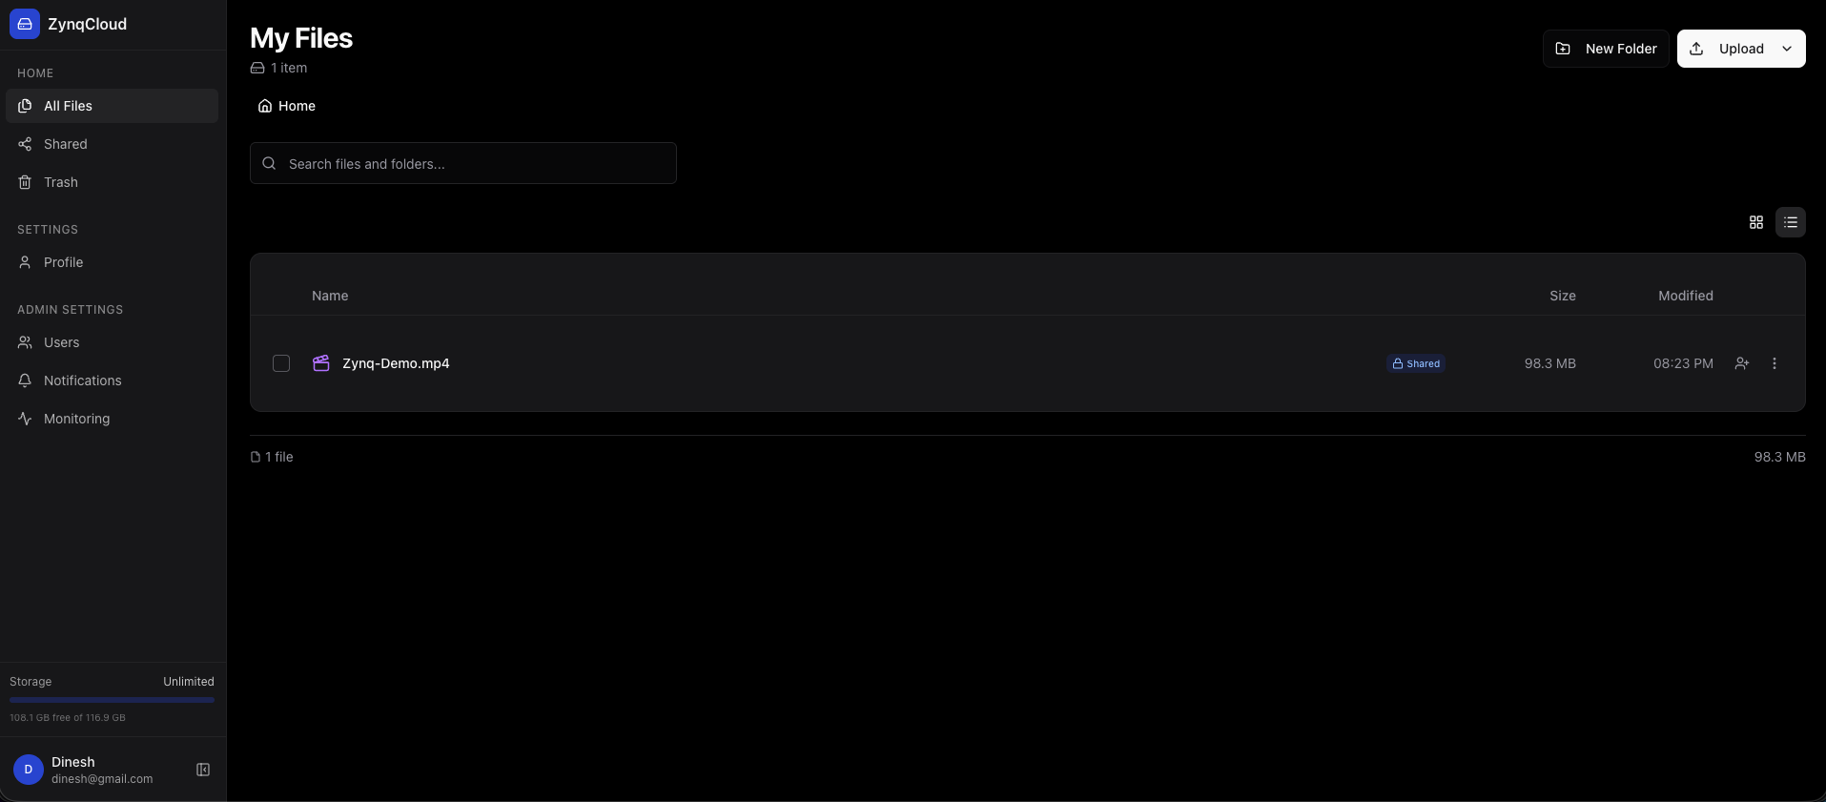

File Sharing Dialog:
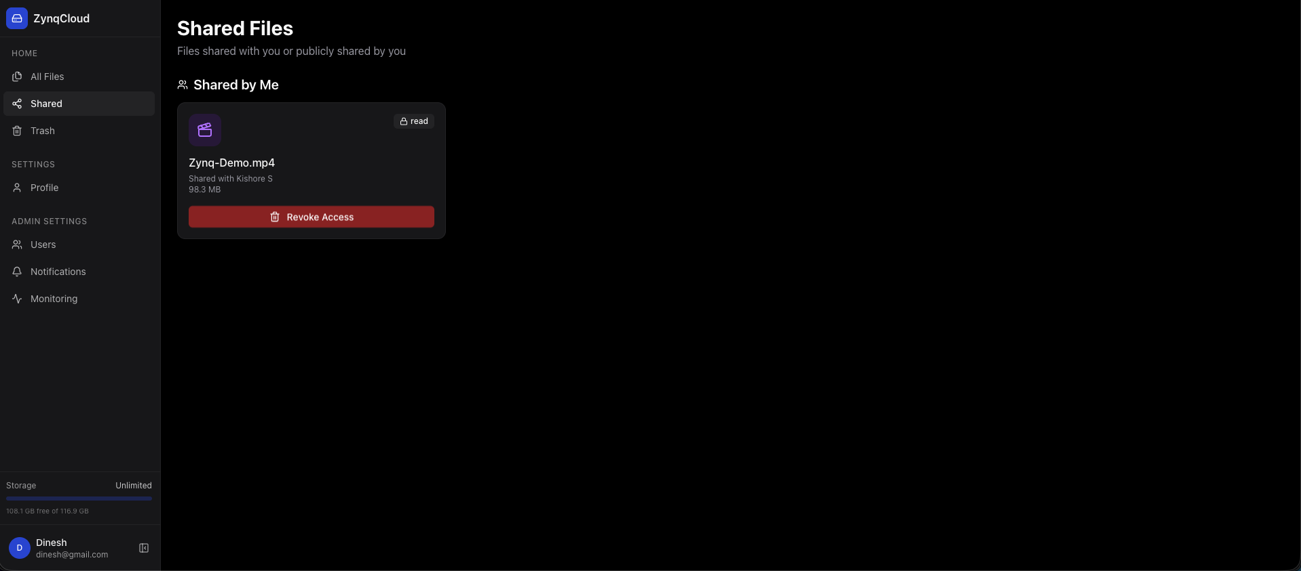

Public Share Access Page:
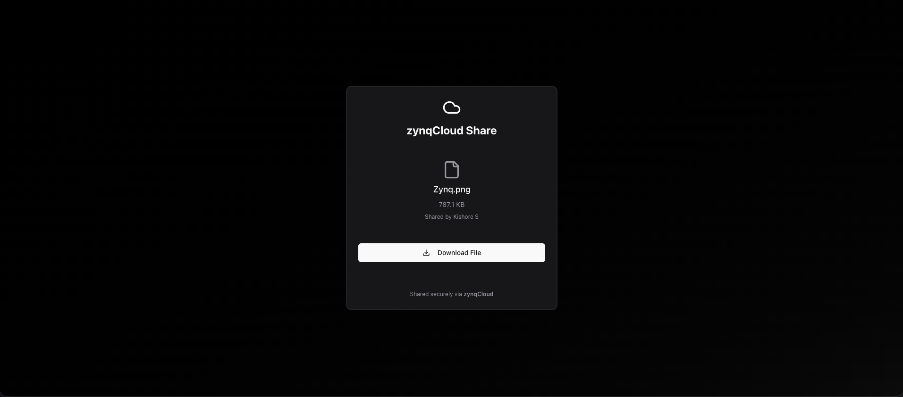

Admin - User Management:
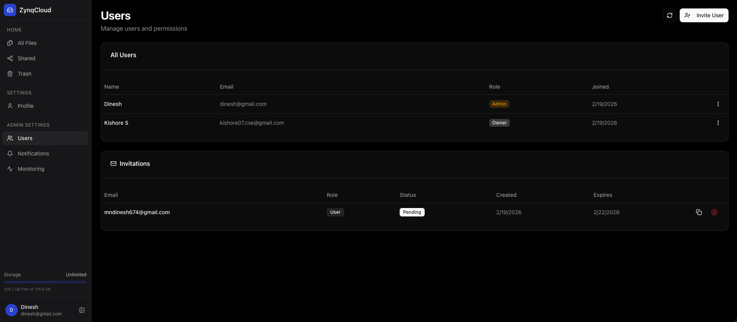
Admin - Storage Monitoring: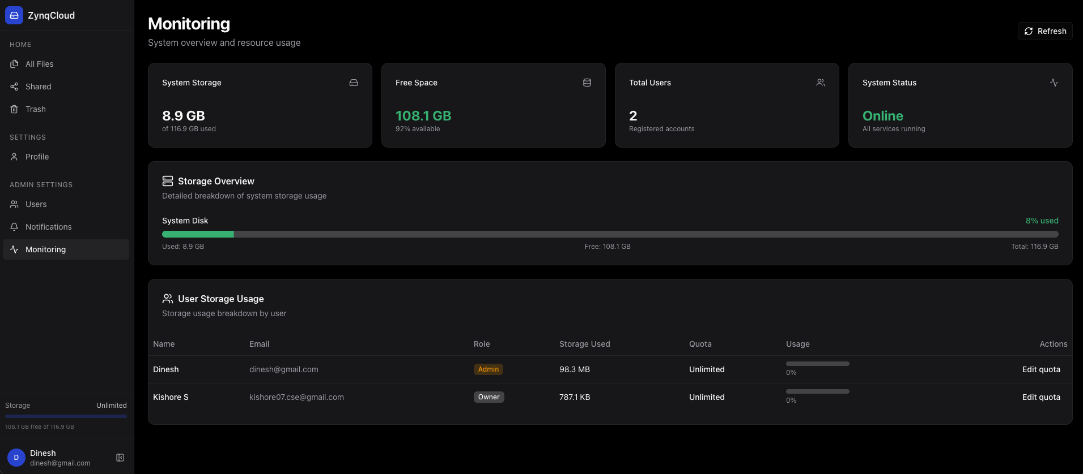

Trash Recovery:
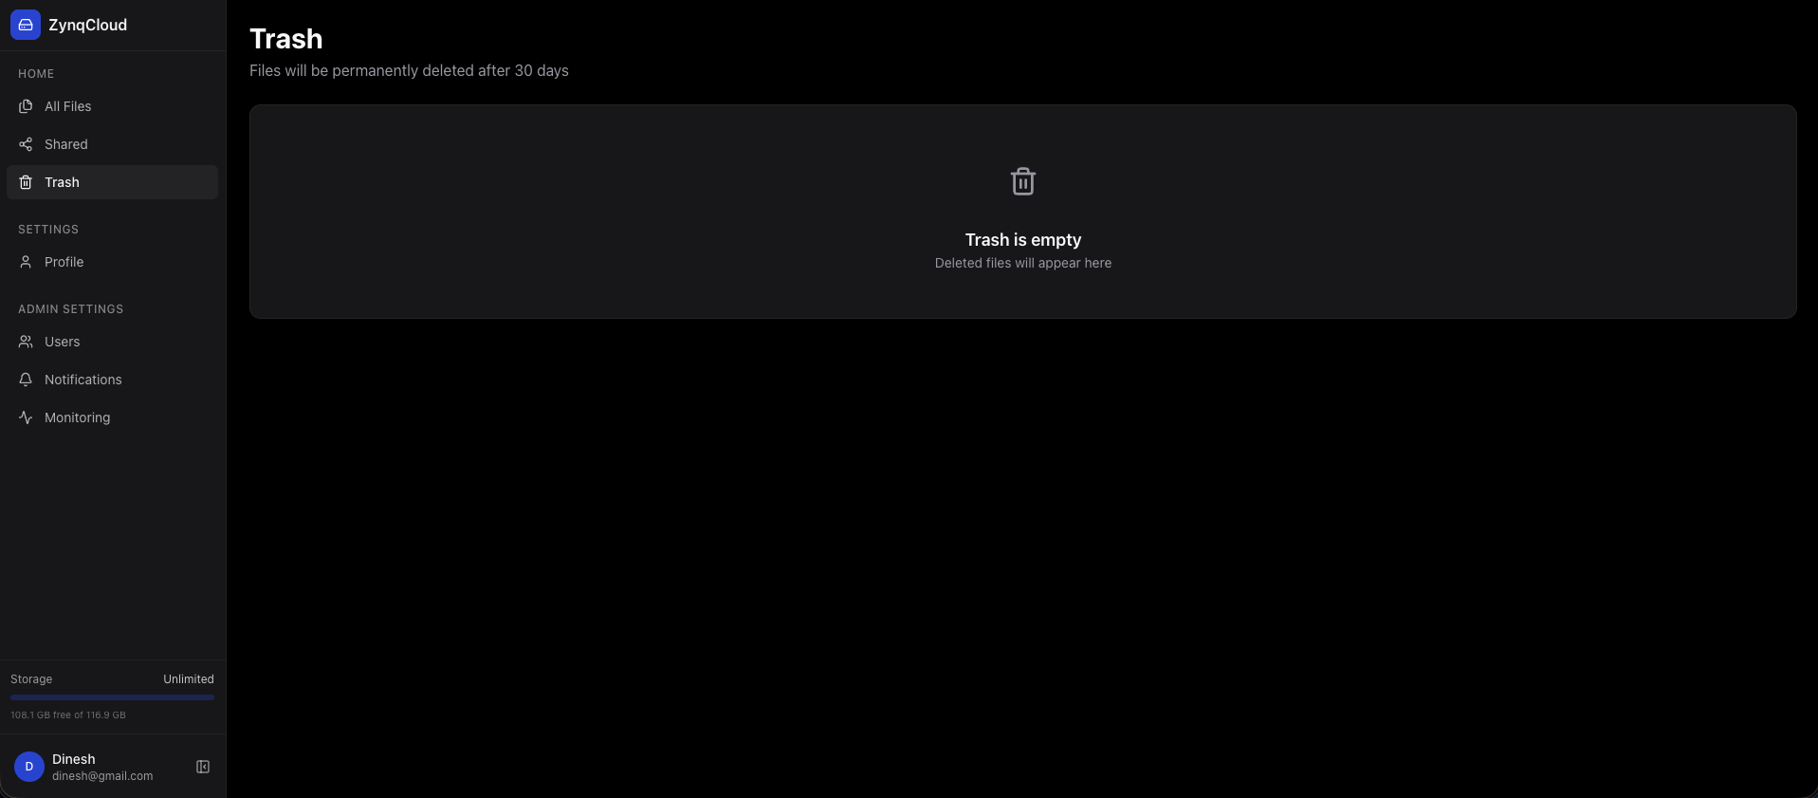

REFERENCES
- O. A. Khashan, "Secure Outsourcing and Sharing of Cloud Data Using a User-Side Encrypted File System," IEEE Access, vol. 8, pp. 210855-210867, 2020, doi: 10.1109/ACCESS.2020.3039163.
- A. K. Singh et al., “Secure File Sharing System Using Big Data in the Cloud,” IEEE ICAC3N, 2023.
- J. Jayachitra et al., “Cloud Storage and Secure File Sharing using Blockchain with XChaCha20 and SHAKE,” IEEE CICN, 2024.
- E. Chen et al., “Secure Remote Cloud File Sharing with Attribute-Based Access Control,” IEEE Transactions on Services Computing, 2023.
- W. Stallings, Cryptography and Network Security: Principles and Practice, Pearson, 7th Edition.

